ITA0610 - Machine Learning
EXP – 8
Write a program to implement Linear Regression (LR) algorithmn python
AIM
To implement the Linear Regression (LR) algorithm using Python and predict the output based on the given dataset.

ALGORITHM
- Import the required libraries.
- Load the dataset.
- Split the dataset into training and testing sets.
- Create the Linear Regression model.
- Train the model using the training data.
- Predict the output using the testing data.
- Display the regression coefficient, intercept, and predicted values.
- Plot the regression line and display the result.

PROGRAM:
import numpy as np
import pandas as pd
import matplotlib.pyplot as plt
from sklearn.model_selection import train_test_split
from sklearn.linear_model import LinearRegression
from sklearn.metrics import mean_squared_error, r2_score

data = {
'Experience': [1, 2, 3, 4, 5, 6, 7, 8, 9, 10],
'Salary': [30000, 35000, 40000, 45000, 50000, 55000, 60000, 65000, 70000, 75000]
}
df = pd.DataFrame(data)
X = df[['Experience']]
y = df['Salary']
X_train, X_test, y_train, y_test = train_test_split(
X, y, test_size=0.2, random_state=42
)
model = LinearRegression()
model.fit(X_train, y_train)
y_pred = model.predict(X_test)
print("Coefficient:", model.coef_[0])
print("Intercept:", model.intercept_)
print("\nPredicted Values")
for actual, predicted in zip(y_test, y_pred):
print("Actual:", actual, "Predicted:", round(predicted, 2))
print("\nMean Squared Error:", mean_squared_error(y_test, y_pred))
print("R2 Score:", r2_score(y_test, y_pred))
plt.scatter(X, y)
plt.plot(X, model.predict(X))
plt.xlabel("Experience")
plt.ylabel("Salary")
plt.title("Linear Regression")
plt.show()

OUTPUT:
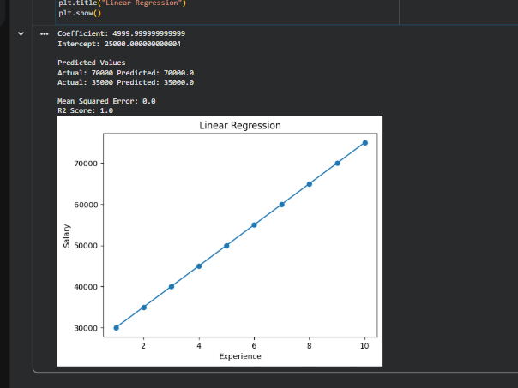

RESULT:
Thus, the Linear Regression (LR) algorithm was successfully implemented using Python. The model was trained on the sample dataset, predicted the output values, and generated the regression line. The model achieved a high prediction accuracy with an R² score close to 1, indicating a good fit for the given data.

